# 01/24/2019 - Capstone Meeting Notes

**Discussions:**

* Step 1 for analysis use lumped mass and assume negligible thickness of material, determining total temp after 5 min

**Progress:**

* Parker
  + ·······Nothing new
* Katherine
  + PSAS: Still working on getting full ANSYS on computers

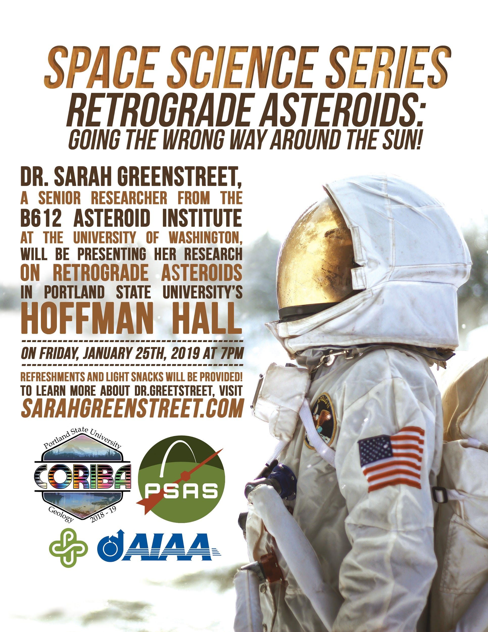

* + This event & food is free & open to all, but [tickets](https://portlandstate.universitytickets.com/w/event.aspx?id=1563&r=a28ea5c50afe4180ab99ba6b79bf71d2) are required but it is 7pm on a Friday
  + Completed next module in edX
  + No progress on hand calcs (FEA assignment this week kicked my ass)
  + ORSAT may have found lower temperature range values
* Tom
  + Started Module 4 Edx.
  + Worked on the hand calculations with Jeremy.
* Jeremy
  + Completed edx module 2, working on 3
  + Hand calcs: ODE established, working on solving it
  + Still need to re-do ansys model of aluminum shell
* Griffin
  + Did not get much done this week. Was busy between school and work.
  + Almost finished with the 2nd edx module.
  + Should be able to catch back up this weekend as I have no work or track
* Tyler
  + Almost completed module 3 but my laptop crashed last night so I will finish it up today.
  + Hand calcs completed-ish, however do not feel comfortable with my results. Would strongly like to discuss and video chat so we can share calcs/ideas.
  + Katherine covered the PSAS meeting this week
  + Would like to clean up hand calcs this week and complete module 4

**Action Items:**

* Create update presentation
* Hand calcs -> MATLAB ODE solver

**Important notes for Ansys and the calculations:**

* First: Analyze the temperature reached after 5 mins given the scenario of one directly in the view of the sun (see the picture on the next page).

IF Temperature exceeds 60 C within the allotted time:

Determine when Temperature reached 60 C

ELSE Temperature does not reach 60 C within allotted time:

Determine when Temperature will reach 60 C

**Important dates:**

* Update presentation (February 5th)

